Saudi Arabia Becomes 51st Country to Accede to TAC

Jakarta, 12 July 2023 – Saudi Arabia has become the 51st country to accede to the Treaty of Amity and Cooperation (TAC). The accession signing ceremony was carried out on the sidelines of the 56th ASEAN Foreign Ministers' Meeting (AMM) in Jakarta (12/7).

Indonesian Foreign Minister Retno Marsudi, on behalf of ASEAN, expressed her appreciation to Saudi Arabia.

"Saudi Arabia is now the 51st country to sign the TAC. This shows Saudi's strong commitment to adhere to the ASEAN values and principles as embodied in the TAC," said Foreign Minister Retno.

By signing the TAC, Saudi Arabia is committed to cooperate and collaborate, uphold international law, and contribute to peace and stability in Southeast Asia and beyond. These values and principles are increasingly important amid current geopolitical dynamics.

"We welcome Saudi Arabia to the ASEAN Family. Together, we must be a positive force for peace, stability and prosperity in the Indo-Pacific region," the Foreign Minister said.

The signing of the TAC was carried out by Saudi Arabia's Foreign Minister Faisal bin Farhan Al-Saud and witnessed by ASEAN Foreign Ministers and the ASEAN Secretary General. Before Saudi Arabia, the last country to accede to the TAC was Ukraine in 2022. Meanwhile, the first country outside of ASEAN to accede to the TAC was Papua New Guinea in 1989.

***

For further information, please contact the following:

Director for Information and Media of the Ministry of Foreign Affairs - Hartyo Harkomoyo (+62811831899)

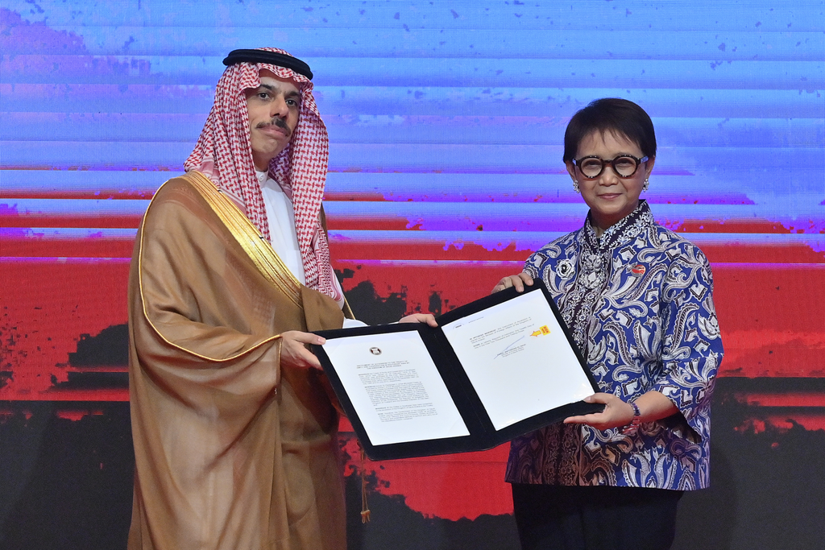

Saudi Arabia has become the 51st country to accede to the Treaty of Amity and Cooperation (TAC) on the sidelines of the 56th ASEAN Foreign Ministers' Meeting (AMM) in Jakarta (12/7) (Photo: Ministry of Foreign Affairs of Indonesia).

